**Measurement of Power in R-L-C series circuit**

**Name:** Adwait S Purao

**UID:** 2021300101

**Branch:** Computer Engineering

**Batch:** B2

**CIRCUIT DIAGRAM:**

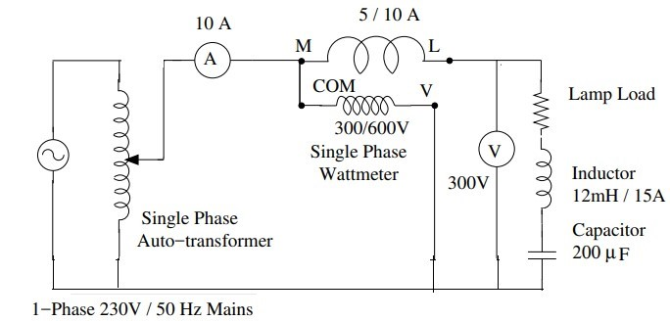

**OBSERVATION TABLE:**

|  |  |  |  |  |  |  |  |
| --- | --- | --- | --- | --- | --- | --- | --- |
| **Sr. No.** | **VS (V)** | **IS(A)** | **VR(V)** | **Vcoil(V)** | **VC(V)** | **Active Power (P) (Watts)** | **No. of**  **ON bulbs** |
| **1** | 230.2 | 2.99 | 219 | 12.1 | 4.8 | 658 | 4 |
| **2** | 230.2 | 5.80 | 204 | 22.76 | 93.2 | 1220 | 8 |
| **3** | 230.2 | 4.42 | 213 | 17.67 | 70.7 | 960 | 6 |

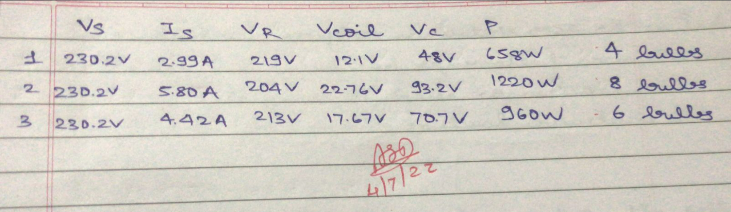

**CALCULATIONS:**

**Useful formulae:**

Apparent power S= VS*IS

Power Factor=P/ S

Total circuit impedance ZS=VS/IS

Coil impedance Zcoil=Vcoil/IS

Resistance of Lamp load R=VR/IS

Capacitive reactance XC=VC/IS

The parameters of the circuit can be obtained by solving following two equations:

ZS2=(R+r)2+(XL-XC)2 and Zcoil2=r2+XL2

Impedance Triangle (For XL>XC)

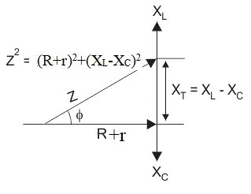

**EXPERIMENT No: 5 DATE: 04 / 07 / 2022**

# **Measurement of power in R-L-C series circuit**

**AIM:** 1) To obtain different types of power in R-L-C series circuit.

2) To verify the parameters used in the circuit with the help of the readings taken and vector diagram.

**APPARATUS AND COMPONENTS REQIRED:**

Single phase auto-transformer (10A), Ammeter (0-10A), Wattmeter (10A/300V), Voltmeter (0-300V), Lamp-load, Inductors (12mH/10A), Capacitors (200µF), connecting wires.

**THEORY:** Write theory related with following questions:

1. Explain the behavior of series R-L-C circuit when single phase ac supplied is passed through it. Draw vector diagram for the same.
2. What is true, imaginary, and apparent power? Explain its significance.

**PROCEDURE:**

1. Connect the circuit as shown in the circuit diagram.
2. Adjust VS=230 V using auto transformer. Note down readings of ammeter (IS) and wattmeter (P). Also measure VR, VL and VC using multimeter.
3. Calculate apparent power S.
4. Obtain power factor from S and P.
5. Calculate resistance of lamp load R, resistance of coil r, reactance XL and XC.
6. Obtain L and C from XL and XC respectively.
7. Vary the load (Change the number of on bulbs).
8. Repeat steps 3) to 6).
9. Draw phasor diagram.

**Behavior of series R-L-C circuit when single phase ac supplied is passed**:

*Resistance*, *Inductance*, and *Capacitance* have very different phase relationships to each other when connected to a sinusoidal alternating supply.

In a pure ohmic resistor the voltage waveforms are “in-phase” with the current. In a pure inductance the voltage waveform “leads” the current by 900, giving us the expression of: ELI. In a pure capacitance the voltage waveform “lags” the current by 900, giving us the expression of: ICE.

This Phase Difference, Φ depends upon the reactive value of the components being used and hopefully by now we know that reactance, ( X ) is zero if the circuit element is resistive, positive if the circuit element is inductive and negative if it is capacitive thus giving their resulting impedances as:

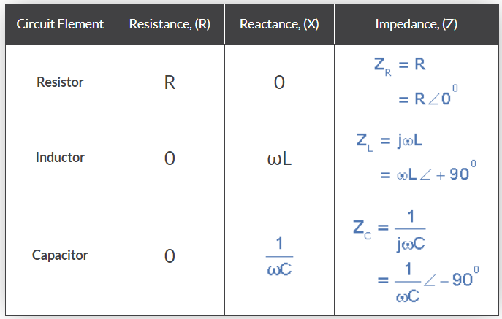

**Impedances of R, L and C components**

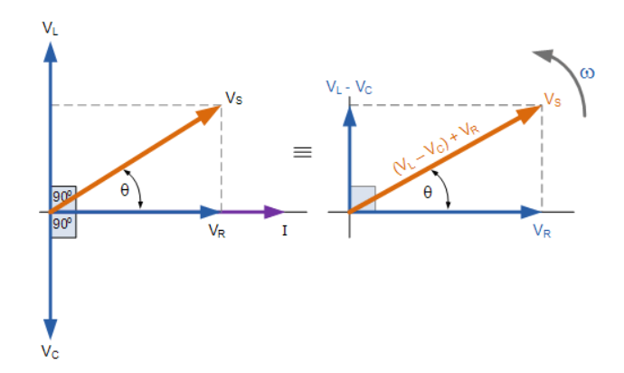

**Phasor Diagram**

**True Power:** In an AC circuit, true power is the actual power consumed by the equipment to do useful work. It is distinguished from apparent power by eliminating the reactive power component that may be present.

The true power is measured in watts and signifies the power drawn by the circuit’s resistance to do useful work. In a single phase system, the true power;

P = VI cos Φ

Other names that refer to True Power are, real power, actual power Useful power, or Watt-full power.

**Imaginary Power:** We know that reactive loads such as inductors and capacitors dissipate zero power, yet the fact that they drop voltage and draw current gives the deceptive impression that they actually do dissipate power.

This “phantom power” is called reactive power, and it is measured in a unit called Volt-Amps-Reactive (VAR), rather than watts.

The mathematical symbol for reactive power is the capital letter Q.

**Apparent Power:** The combination of reactive power and true power is called apparent power, and it is the product of a circuit’s voltage and current, without reference to phase angle.

Apparent power is measured in the unit of Volt-Amps (VA) and is symbolized by the capital letter S.

**CALCULATIONS:**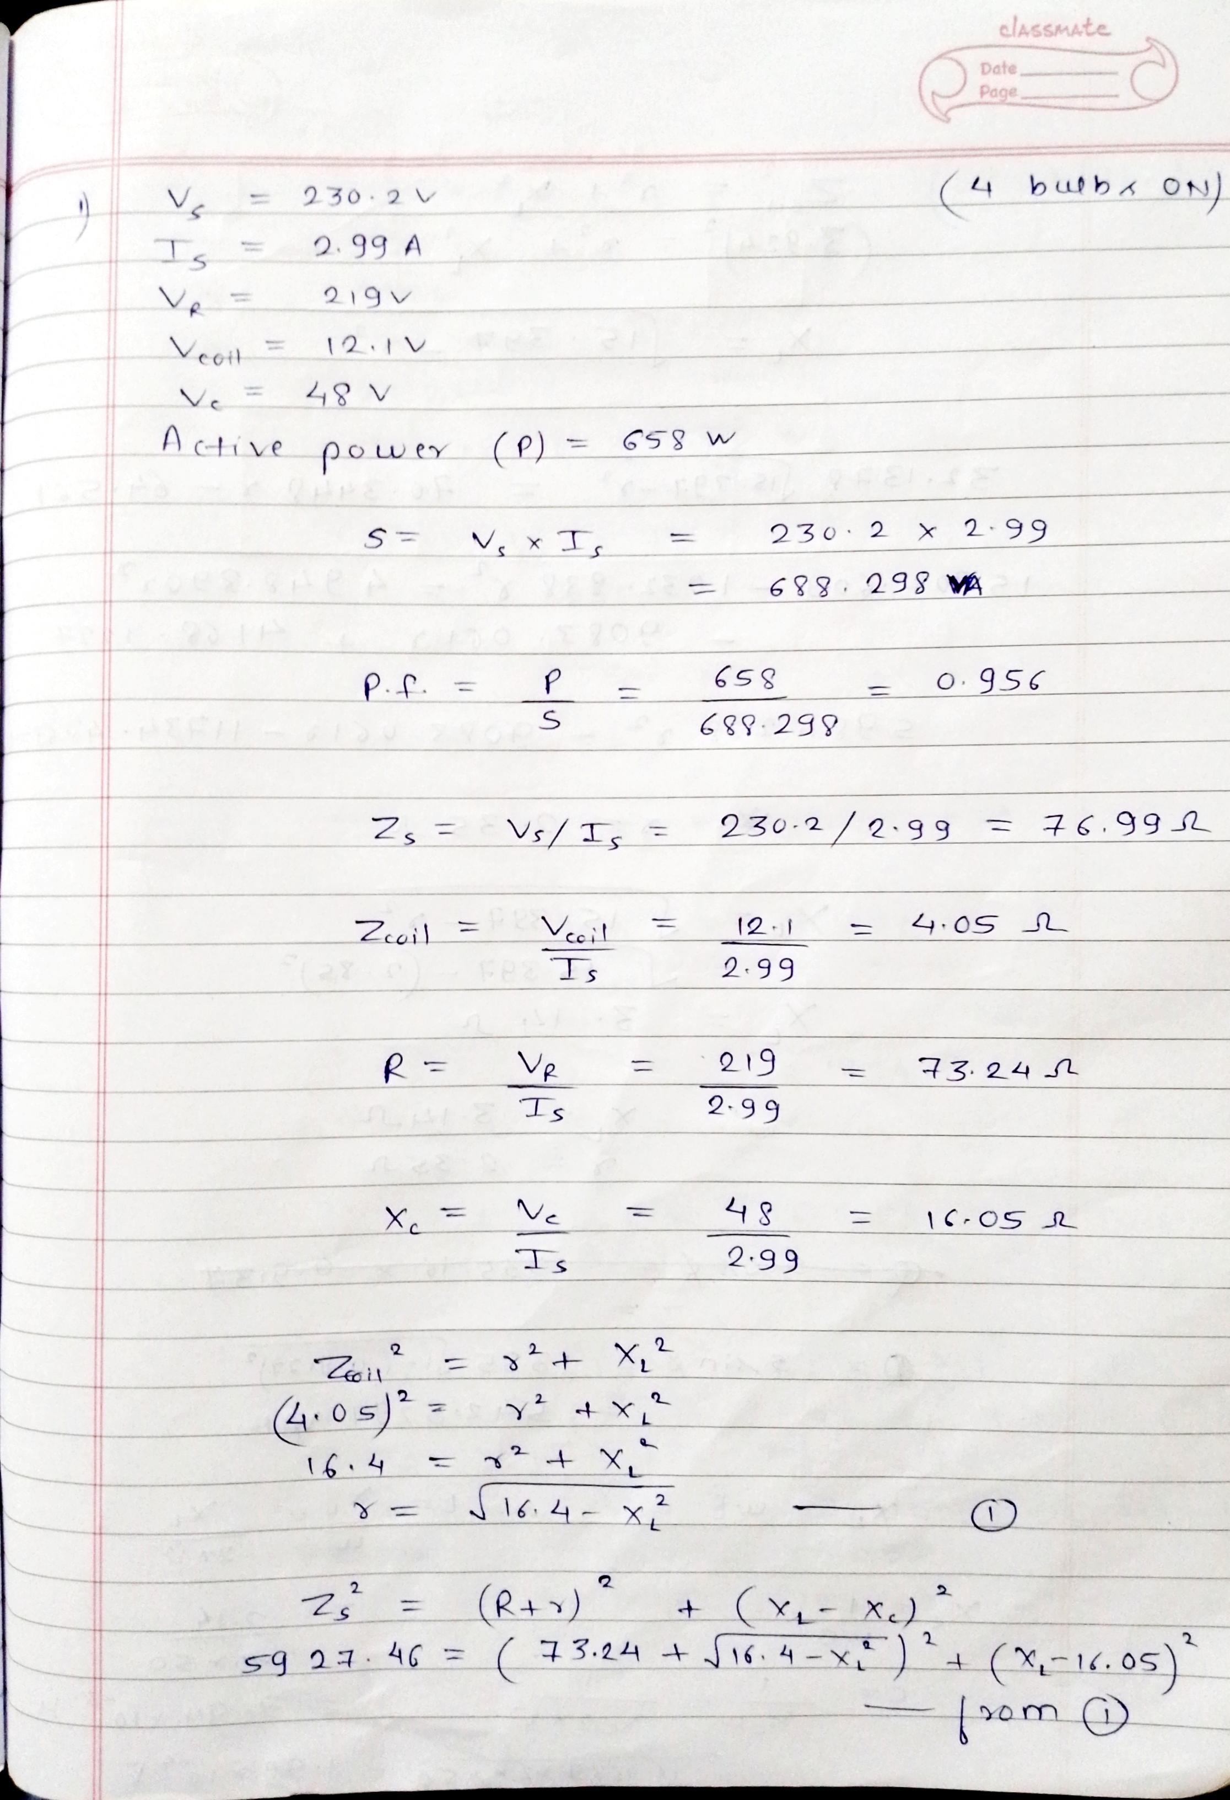 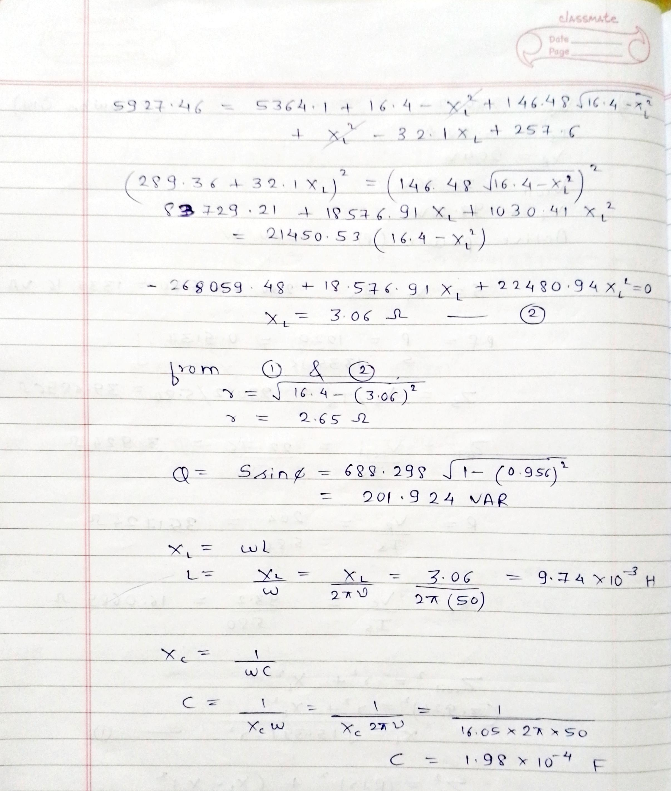 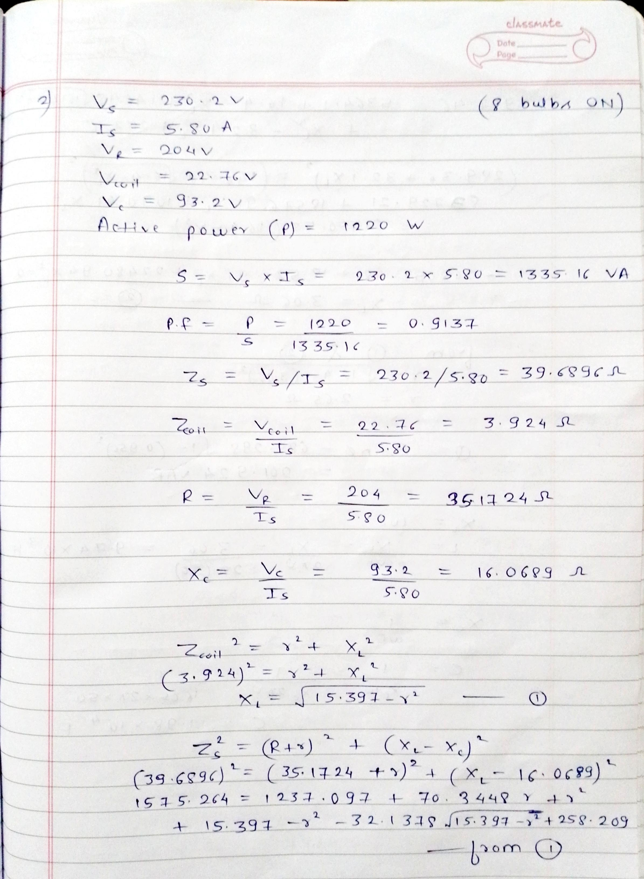 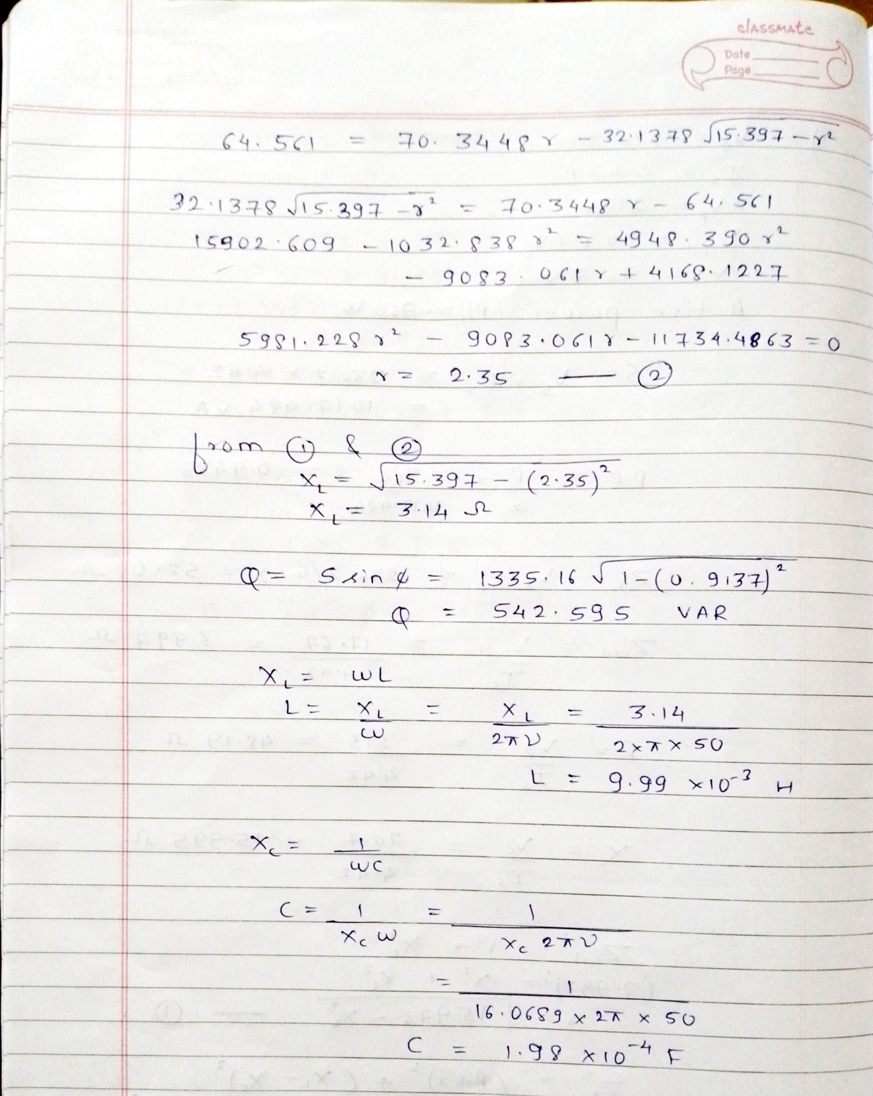 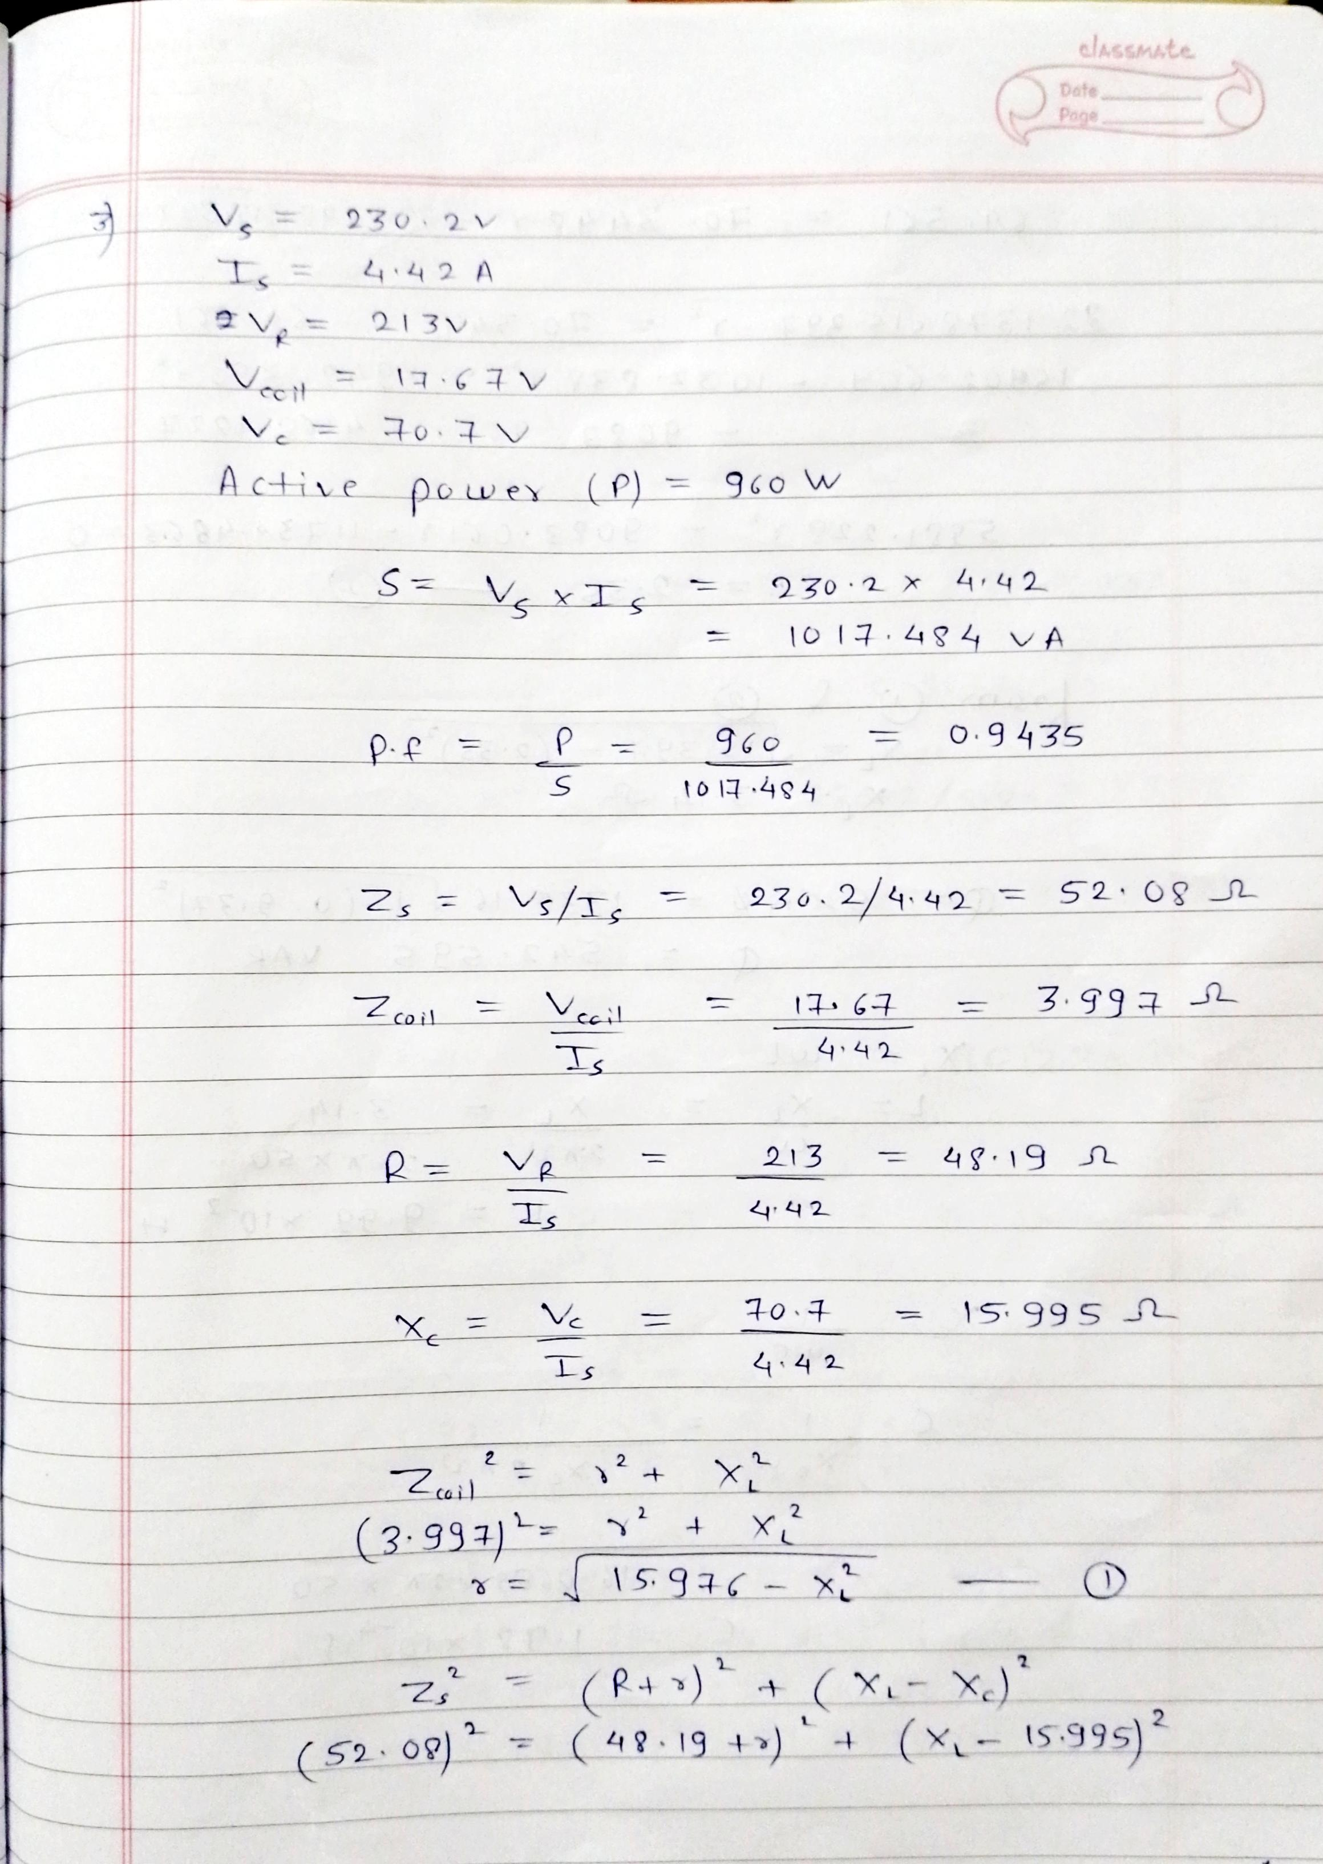 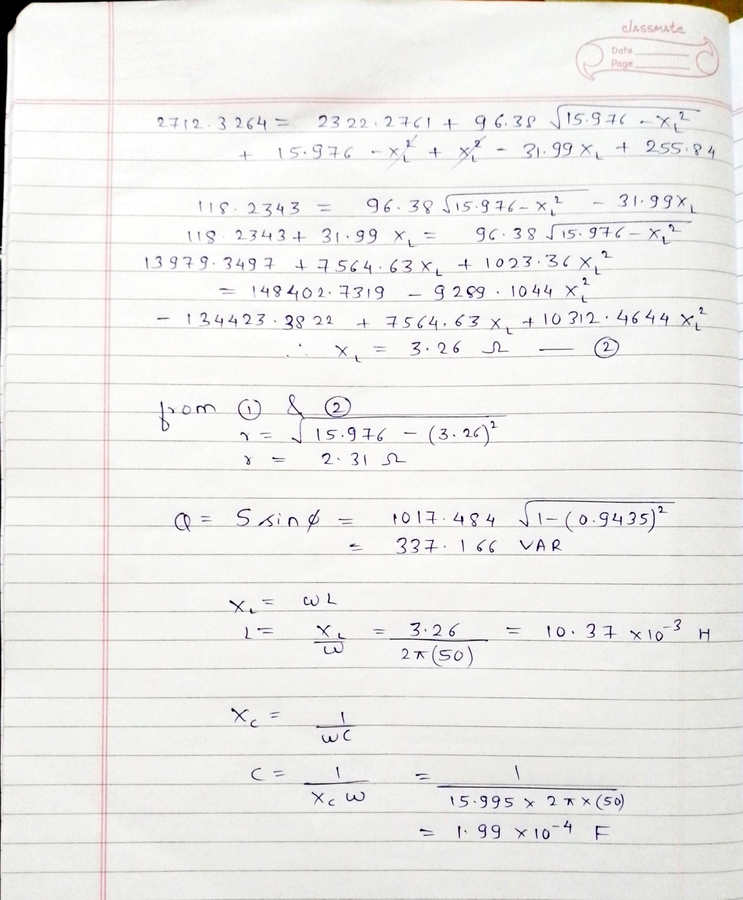

**RESULT:**

|  |  |  |  |  |  |  |  |  |
| --- | --- | --- | --- | --- | --- | --- | --- | --- |
| **Parameter** | **R** | **r** | **L** | **C** | **P** | **Q** | **S** | **Power Factor** |
| Is=2.99A | 73.24 | 2.65 | 9.74*10-3 | 1.98*10-4 | 658 | 201.924 | 688.298 | 0.956 |
| Is=5.80A | 35.1724 | 2.35 | 9.99*10-3 | 1.98*10-4 | 1220 | 542.595 | 1335.16 | 0.9137 |
| Is=4.42A | 48.19 | 2.31 | 10.37*10-3 | 1.99*10-4 | 960 | 337.166 | 1017.484 | 0.94 |

**CONCLUSION:**

